PT 8608
Black Burst Module

and

PT 8609
SDI Black/Color bar Module

The PT 8608 Black Burst Module and the PT 8609 SDI Black/Color bar Module can be installed in the
PT 5210 VariTime™ Digital Sync generator.
The PT 8608 can be installed in the PT5230 Digital Video Generator or PT5300 HD-SD VariTime™ Sync generator, while the PT8609 is NOT recognized by the PT 5230.
The number of these modules can be up to 3 in total.

Packing list:
Check that the PT 8608/09 options package contains the following items:
 | Description: | Item | Quantity
 | Nut for BNC Connector | 2422 034 17419 | 2
 | Lockwasher for BNC Connector | 2422 034 17421 | 2
 | Pan Screw M3x6 | 2522 178 31058 | 8
 | Washer Brass | 2522 600 10018 | 16
 | Ribbon Cable with micro 20 pole connectors | 4008 105 04030 | 1
 | Distance Piece M3 | 4008 107 36490 | 8
7a. | Analog Bl. Burst Generator Assy | 4008 109 83280 | 1 (PT 8608 only)
7b. | SDI Black/Color Bar Module | 4008 109 83290 | 1 (PT 8609 only)

The system is “plug and play” meaning that when a unit is mounted no configuration is needed in order to enable the new unit.

Installation procedure:
- Open the PT 5210/PT5230/PT5300 by removing the top cover.
- Remove the plastic blinds from the back panel for the module to be installed. The PT 8608 and PT 8609 can be installed to use the connectors numbered 3-4, 5-6 and 7-8. It is recommended to use the lower numbered outputs before the higher numbered output and when both PT 8608 and PT 8609 are used the PT 8608 module(s) should be installed to use the lowest output numbers. This will make the menu operation simpler.
- Insert the module(s) to be placed in the bottom part of the chassis.
Mount the lockwasher and nut on the BNC connectors, do not tighten.
- Case 1: No modules in the upper section.
Install the 8 screws through each of the modules, do not tighten.
Tighten the nuts on the BNC connectors.
Tighten the screws through the modules.
- Case 2: One PT 8608 or PT 8609 module to be installed in the upper section.
Install the eight hexagonal spacers in the screw holes below the position where the upper module will be installed.
Install the two times four screws in the remaining screw holes in the two modules in the lower position.
Tighten the nuts on the BNC connectors.
Tighten the screws and hexagonal spacers holding the lower modules.
- When required, insert the module in the upper position.
Mount the lockwasher and nut on the BNC connectors, do not tighten.
Mount the 8 screws through the module into the hexagonal spacers.
Tighten the nuts on the BNC connectors.
Tighten the screws through the modules.
- Mount the ribbon cables from the module(s) printed circuit board to the PT 5210 main board. Observe that the cable is correctly turned. A guide pin in one end of the connectors should fit into a hole in the PCB.
- Mount the top cover.
- Turn on power while performing a “factory reset” as described in the manual. Observe that the menu includes the new installed generators.
- Place the option type plate on the side of the generator in order to make later identification possible.
Picture 1
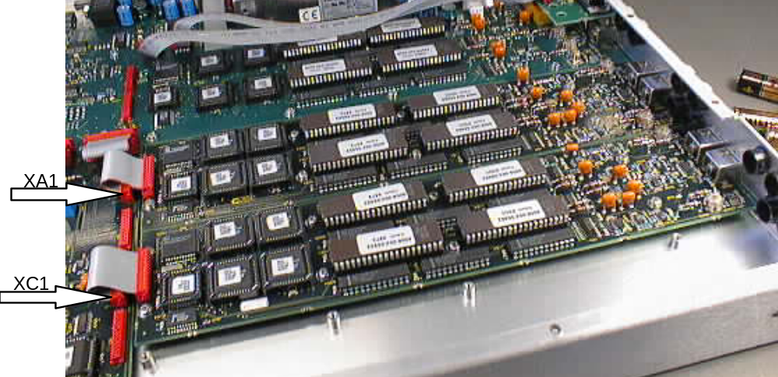
Picture 1: The positioning of two modules PT 8609 installed in a generator frame. When only one module is installed this should be the placed to use BNC connector 3 - 4 and cable connector XA1.
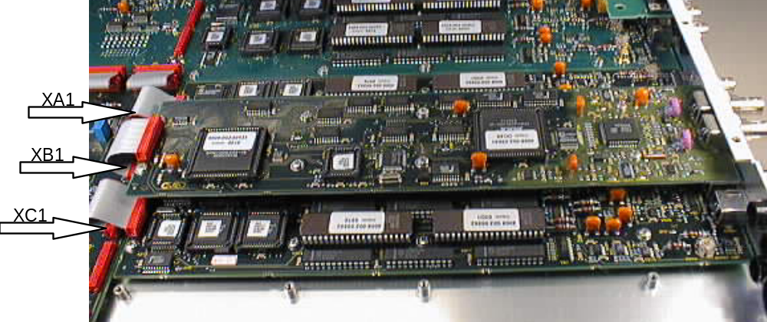
Picture 2.

Picture 2: The installation of three modules PT 8608 and/or PT 8609 requires that one module is installed in the upper level. Eight hexagonal spacers has to be used to give distance to the lower modules. The cables from the three modules should be connected to XA1, XB1 and XC1 respectively.

